ER Model for Teachers Pay Teachers (TpT)

**About TpT:**

**Teachers Pay Teachers** is an online marketplace for teachers that connects teachers across the globe. TpT allows teachers to buy, sell, or share their educational materials with other teachers for free. To read more about TpT, please visit <https://www.teacherspayteachers.com/Help>

**Assignment Summary:**

A database design project generally starts with the requirements. You, as a database developer, work with business users to gather and analyze the requirements. These requirements are then used to identify the business rules, entities, and relationships, which are used to create the ER model and the physical database. For this assignment, however, we are going to reverse engineer an ER model and a database using screenshots from a functional website (www.teacherspayteachers.com). TpT website screenshots are provided for your reference, however, you may go through the TpT website to understand the buyerand sellerworkflows.

**Scope:**  
A website has many moving parts including registration, payments, etc. The scope of this assignment, however, is limited to only *Sales* and *Reviews*. When you go through the website workflows, pay close attention to the sales and reviews related entities. Anything outside of sales and reviews is considered out of scope for the assignment.

**Assumptions:**

* A seller/buyer can sign up using an email address
* A seller can be also be a buyer
* TpT keeps a percentage of each sale transaction as a service fee (out of scope)
* A seller, when listing a material, provides information such as subject, grade levels, resource type, price, book picture, file type, file size, number of pages, product description, answer key availability, teaching duration, etc. Capturing every single one of these is not necessary for the assignment.
* A buyer can leave reviews for the product purchased.
* The system should keep track of sales transaction.

Other functionality not mentioned in the assumptions can be considered ‘out of scope’. Simply put, the scope is limited to sales and reviews only. Do not overthink about the website functioning and other things that are out of scope.

**Hint: How to get started:**

* Finalize your design on paper before you implement it in MySQL. This will help you with understanding how everything connects to everything.
* Go through the screenshots provided to understand the working of the website. Although not necessary, you may find going through the seller registration process helpful. You can also try posting a material listing (do not submit) to gather attibutes.
* Identify the entities that you must have and ones that you might need.
* Capture attributes for each entity and determine the functional dependencies.
* Determine the relationships between entities. Hint: When forming the relationship statements, start the sentence with One/Each. Example: **One/Each** department has many employees; **One/Each** employee works for one department.
* Identify the minimum cardinality (optional).
* Implement the ER model in MySQL.
* Create a physical database by using the reverse engineering feature in MySQL Workbench.
* Populate sample data in the database.

**Table Naming Convention:**

Use your first name and last initial as the suffix for the table names. For example, my Client table will be named as Client_KashifS

**Tasks and Deliverables**

1. Design an ER model for the application using MySQL Workbench.

2. Implement physical tables in MySQL. You can use MySQL Workbench to translate your ER model into a physical database.

3. Populate your tables with at least 10 records each in MySQL. Populate your name as one of the buyers in the buyer table.

Please make sure that all physical tables and the MySQL model follow the naming convention mentioned above. Not following this requirement may result in a major deduction in your grade. In addition, there is a 5-point penalty per day for late submissions.

**Assignment Submission**

The assignment is to be submitted via Canvas. Please do not email the assignment to the instructor or the TA. The submission should include the following in a .zip file:

1. MySQL file (for the model)

2. Snapshots of MySQL database in a Word document

Please name the .zip file as your FirstName-LastName-Assign#.zip

Note that you will need this database for future assignments.

**Approximate Work Effort**

It will take you roughly 8-12 hours to complete the assignment. Please do not wait till the last minutes to start. You can discuss the assignment with other people in the class. However, discussions do not mean sharing or showing your assignment solution with others. An act of academic dishonesty will result in a ZERO in the assignment.

What kinds of collaboration are considered acceptable?

- Helping classmates with MYSQL installation issues

- Helping classmates with learning MYSQL

- Discussing the assignment and/or business rules with others

What kinds of collaboration are considered not acceptable?

- Sharing or showing your ER model with others

- Sharing or showing your MySQL database with others

- Providing snapshots of your MySQL database to others

**Website Snapshots:**

**Process to become a Seller/ Buyer:**

1. Sign up GMAIL or any email address.

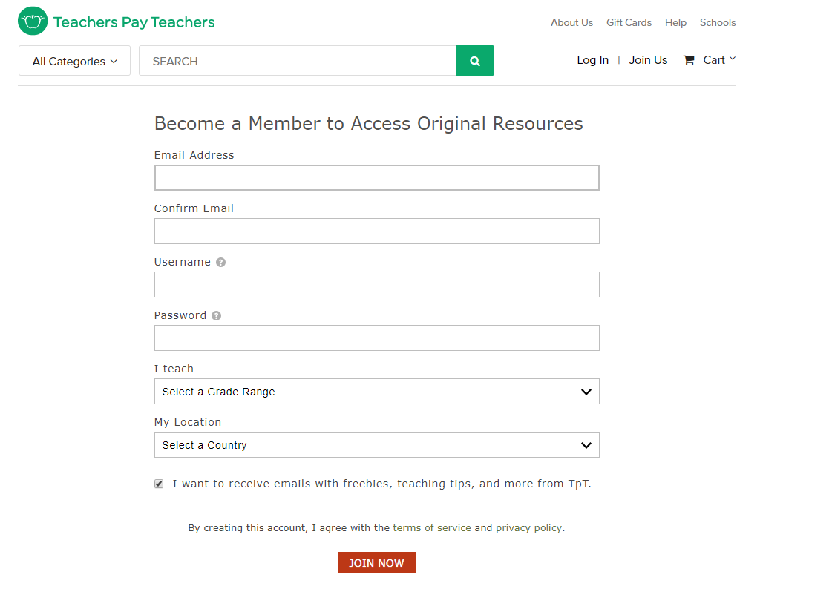

**Become a Seller:**

1. Click on **My TpT** and select ‘**Become a Seller’** and provide the basic information.

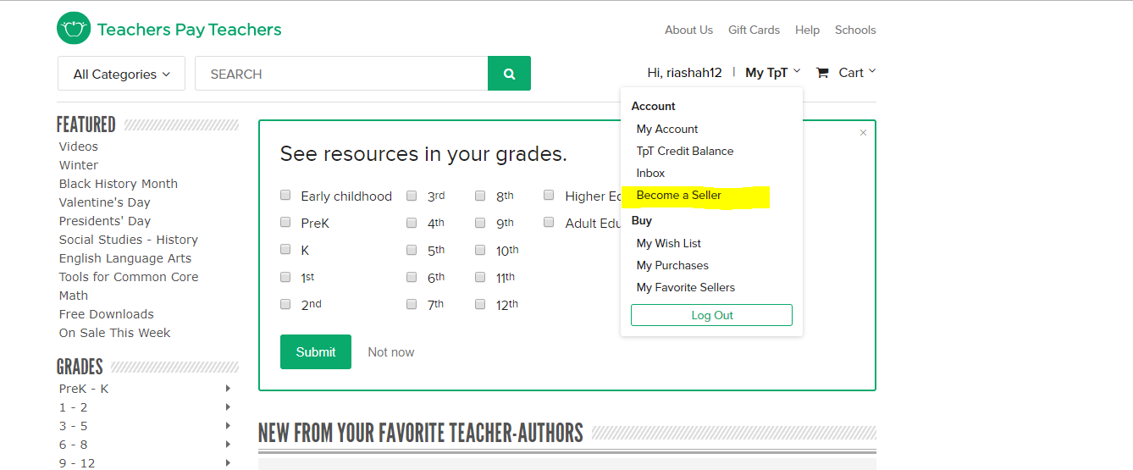

b. The **Seller** can list his/her material by clicking on ‘**Add new product**’ and ‘upload resource’

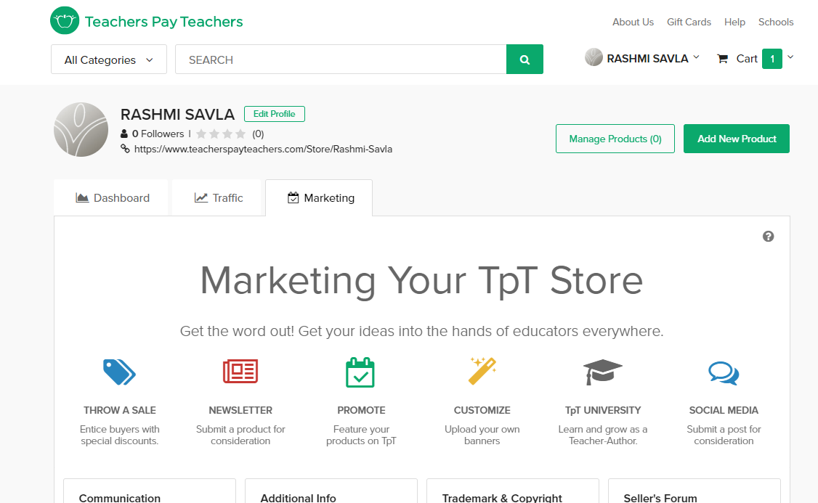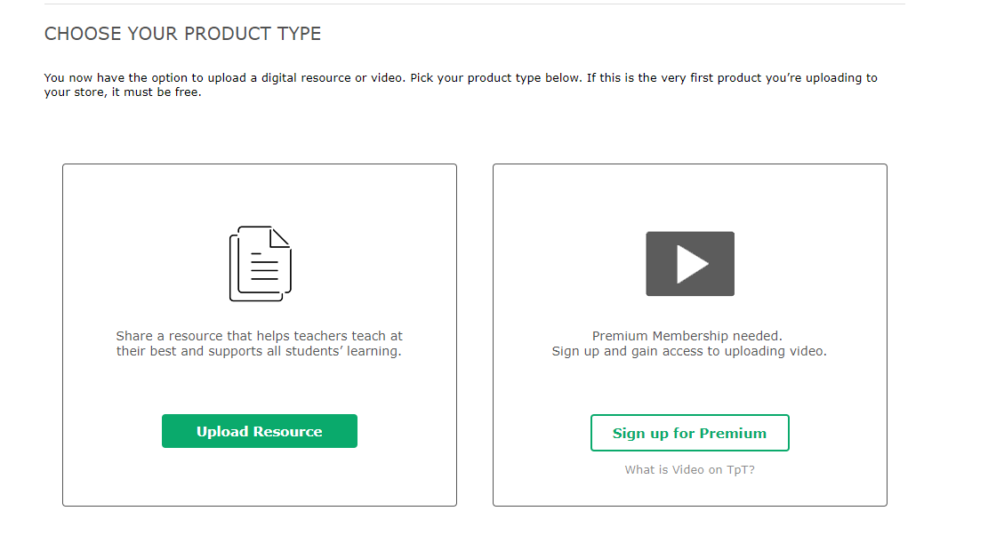

1. The seller needs to provide the Material and the related information
2. The seller needs to provide the Material and the related information:

***Upload Product File, Add Copyright Info, Upload Preview File, Upload a Preview Video for Resource***

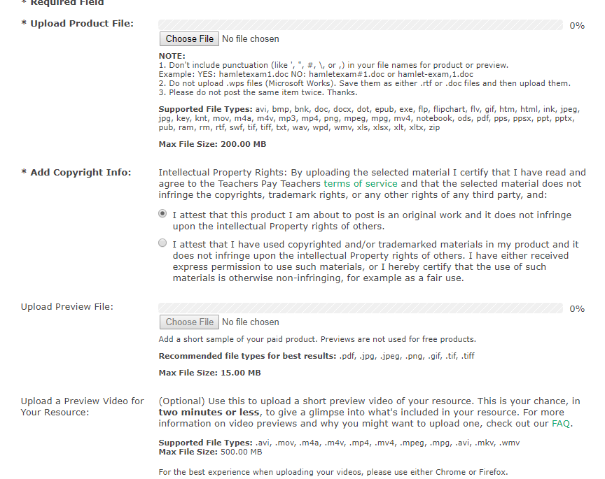

***Add Title, Add Description, Pick Resource Type, Pick Grade Level(s), Choose Subject Area:***

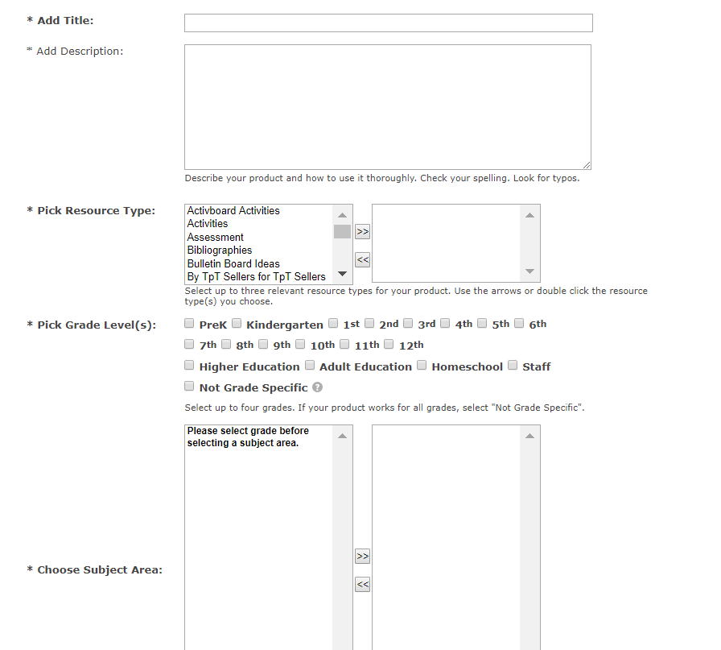

***Add Teaching Duration, Choose Free or Paid, Price, Bundle Discount Price, Add Multiple License Price, Make Product Active, Create Thumbnail Images:***

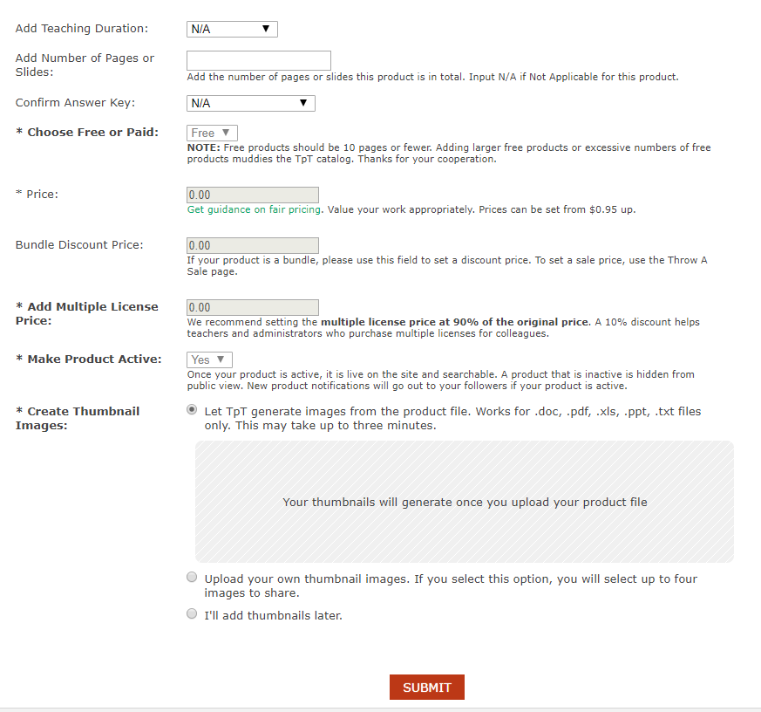

**Become a buyer**

Once the material is active, the buyer can add the material in the cart

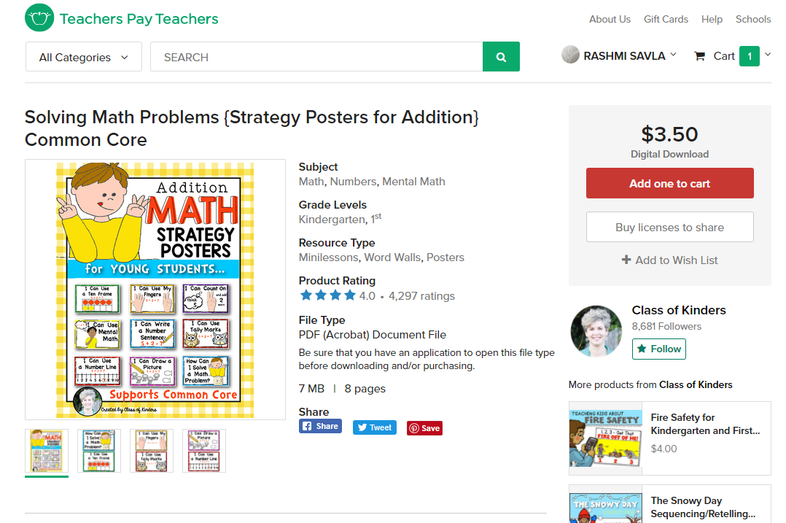 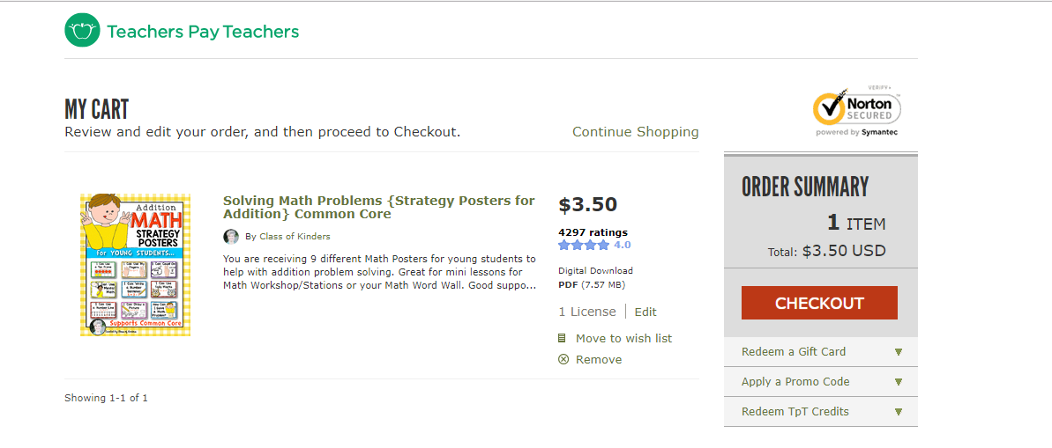

**Buyer** can add the review comments after the purchase. **Buyers** need to update their payment information.

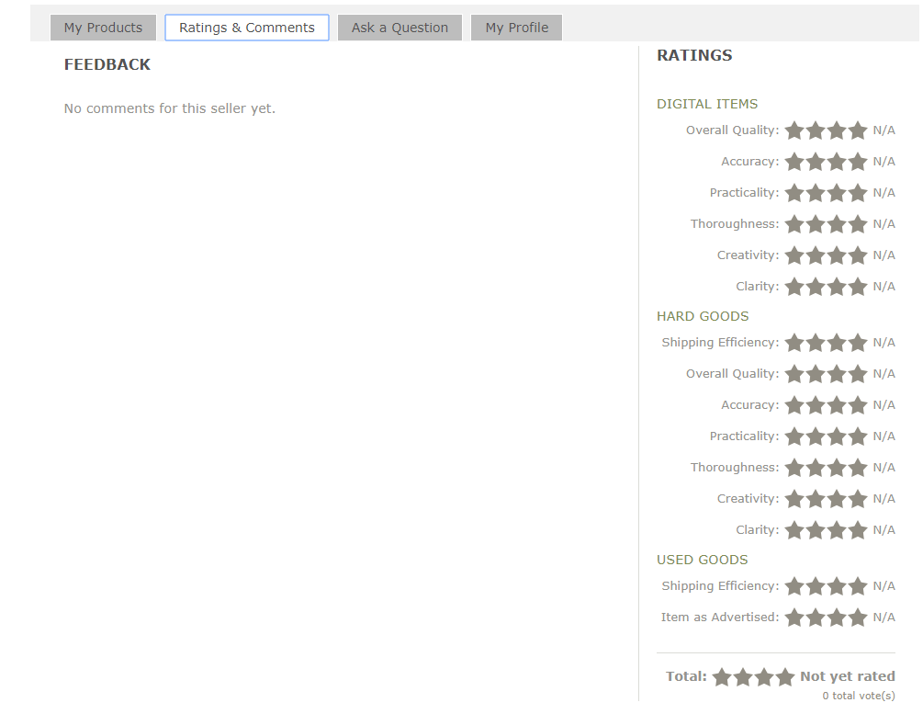

**Summary or Statistic checks**

Buyer can add the material in wish list if the want to buy later. Also, they can check their purchases and favorite sellers

Seller can also check their sales details and product statistics

